About KC Green
The City of Kansas City has been progressive and innovative in its efforts to implement green initiatives, which represent part of a more expansive agenda to make Kansas City a truly sustainable city. Our view of sustainability incorporates green programs into a broader triple bottom line that simultaneously promotes social equity, economic vitality, and environmental quality. Sustainability is a foundation the Mayor, City Council, and City management have established as a top long-term priority in making Kansas City a national leader among local governments. KC Green aims to foster Kansas City’s blueprint for a sustainable future.
Brand Information
KC Green allows co-branding with individuals, businesses, and organizations that are contributing to resilience and sustainability within Kansas City. Two types of co-branding are offered:
Partner Brand – Provided to individuals, businesses, and organizations that have a contract or partnership with the City; Awarded on a 3 year term or consistent with the agreement, if shorter
Recognition Brand – Provided to individuals, businesses, and organizations that do not have a formal contract or partnership with the City; Awarded on a 1 year term

Application Process
The KC Green Policy and Regulations Team administers the application process. The application must be submitted by email or mail:

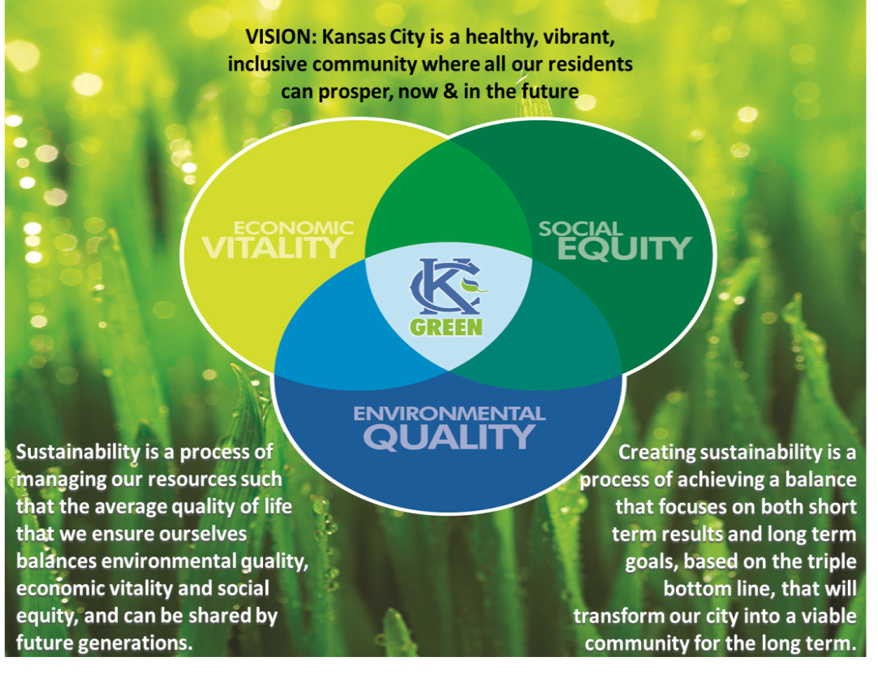
Email: kcgreen@kcmo.org
Mail: City of Kansas City, Mo.
Office of Environmental Quality
KC Green Policy & Regulations Team
414 E. 12th St., Suite 401
Kansas City, MO 64106

The application is available online and can be submitted year-round.

Application results will be announced in June.

Applicants must be in compliance with applicable City ordinances.

Questions regarding the application may be submitted to 816-513-3452 or to kcgreen@kcmo.org
General Application Information
Individual/Business/Organization:
Contact Person(s)
Name:
Phone Number:
Email:
Address:
Position:

Select the Brand for which you are applying
 | KC Green Partner Brand | Provided to individuals, businesses, and organizations that have a contract or partnership with the City; Awarded for up to a 3 year term
 | KC Green Recognition Brand | Provided to individuals, businesses, and organizations that do not have a formal contract or partnership with the City; Awarded on a 1 year term

Please respond to each relevant question. If needed, use a separate page to complete your response, and to provide any additional supporting statements or evidence that verifies your contributions to sustainability and resilience in Kansas City.

Sustainability is defined as a process of managing our resources such that the average quality of life that we ensure ourselves balances environmental quality, economic vitality and social equity, and can be shared by future generations.
- How have you, your business or organization contributed to Kansas City’s sustainability?

Environmental Quality
- How has your work contributed to Kansas City’s environmental quality?

Economic Vitality
- How has your work contributed to Kansas City’s economic vitality?

Social Equity
- How has your work contributed to Kansas City’s social equity?

Sustainability for Future Generations
- How has your work promoted sustainability for future generations?

Measurement of Sustainability Activities
- Do you, your business, or organization measure your sustainability actions? If so, please provide your sustainability indicators and the previous year’s information.

