About KC Green
The City of Kansas City has been progressive and innovative in its efforts to implement green initiatives, which represent part of a more expansive agenda to make Kansas City a truly sustainable city. Our view of sustainability incorporates green programs into a broader triple bottom line philosophy that simultaneously promotes social equity, economic vitality, and environmental quality. Sustainability is a foundation the Mayor, City Council, and City management have established as a top long-term priority in making Kansas City a national leader among local governments. KC Green aims to foster Kansas City’s blueprint for a sustainable future.
Brand Information
KC Green encourages co-branding with all City departments/programs that are contributing to resilience and sustainability in Kansas City.

Application Process
The KC Green Regulations & Policies Team administers the application process. The application can be submitted by email or mail:

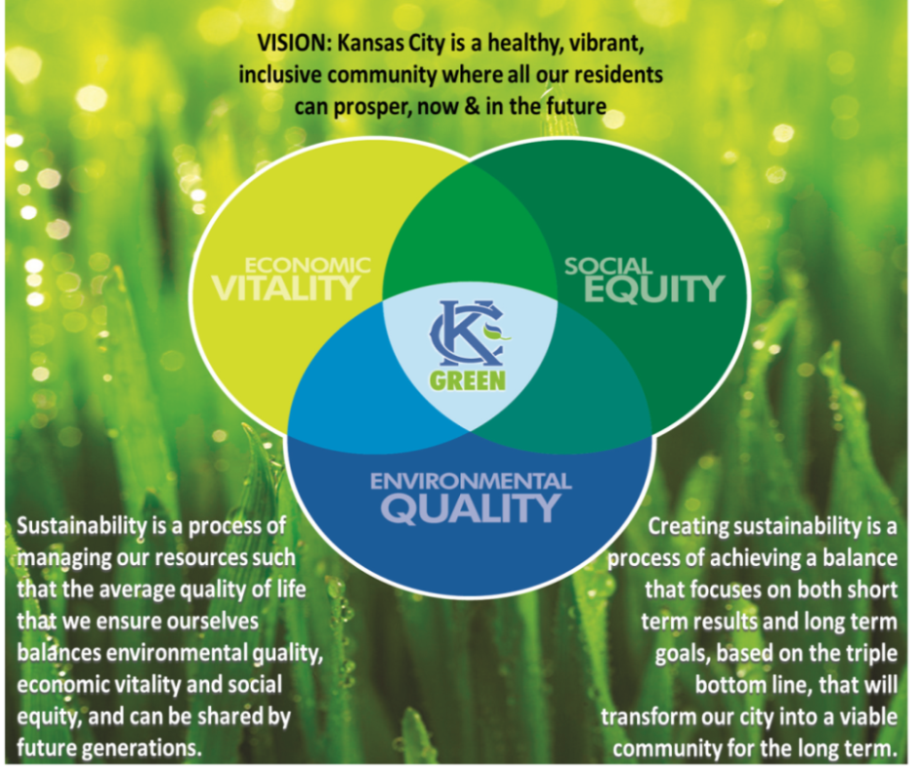
Email: kcgreen@kcmo.org
Mail: City of Kansas City, Mo.
Office of Environmental Quality
KC Green Education & Outreach Team
414 E. 12th St., Suite 401
Kansas City, MO 64106

The application is available online and can be submitted year-round.

Questions regarding the application may be submitted to 816-513-3401 or to kcgreen@kcmo.org

General Application Information
Department:
Contact Person(s)
Name:
Phone Number:
E-mail:
Address:
Position:
Project Title:

Please respond to each question below. If needed, use a separate page to complete your response and to provide any additional supporting statements or evidence that verifies your contributions to sustainability and resilience in Kansas City.

1. | Briefly and clearly describe how the
 | project is green & sustainable; Please
 | include project goals, objectives and
 | metrics; Examples might include:
 | replacing sidewalks with pervious
 | pavement; solar and/or wind energy
 | generation; water conservation or
 | water quality; educational tools; etc
2. | How does the project address the triple
 | bottom line approach? (See below)
3. | Please submit an example, if available | Available and Attached □ Not available □
4. | Time period of intended use
5. | Will the proposed use be to update an existing Brand Use Authorization? | Yes □ No □

Triple Bottom Line of Sustainability is defined as a process of managing our resources such that the average quality of life that we ensure ourselves balances Environmental Quality, Economic Vitality, and Social Equity, and can be shared by future generations. In other words, how do we do the best we can now without damaging the potentials for the future?

