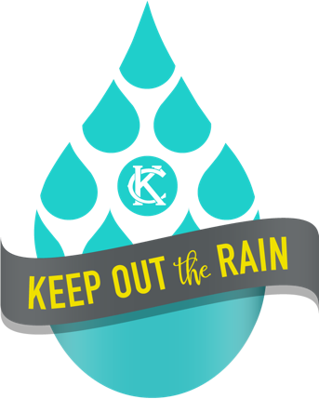
Questions?
Contact:
CDM Smith
Design Professional
Call: (816) -759-2484
E-mail: water.rain.dp2@kcmo.org
Online: www.kcmo.gov/rain

Property Owner Checklist
Thank you for participating in the City of Kansas City, Missouri’s Keep Out the Rain program. During your property’s Sewer Connection Check-up, our Team found one or more plumbing connections that qualify for free repair through this program. The checklist below will help guide you through what to expect as your repairs are scheduled and completed.

This program is one piece of Kansas City’s largest infrastructure investment, the Smart Sewer program, a 25-year, $4.5-5 billion effort to reduce sewer overflows and improve water quality in our region for generations to come.

Next Steps:
_____ ____
1. Sign and submit your Property Owner Agreement. If mailing the agreement, use the postage paid envelope provided to you with the agreement. Contact the Design Professional listed at the top of this sheet with any questions.
2. Meet with the Design Professional and Plumber to review the proposed repair(s) and discuss any questions you may have. We will contact you to schedule this meeting once we have received your signed Property Owner Agreement.
_____
________
3. The Plumber will coordinate with you to set up a time to complete the repair(s).
_____
4. After the repair(s) is complete, the Design Professional and Plumber will visit your home to inspect the completed work and verify the City’s standards and applicable building codes were met. At that time, the Design Professional and Plumber will discuss the repairs that were made and provide any operational, maintenance and/or warranty information with you.

